COINS-Eur-Thrace-Chersonesos-Sear 1602 cf.

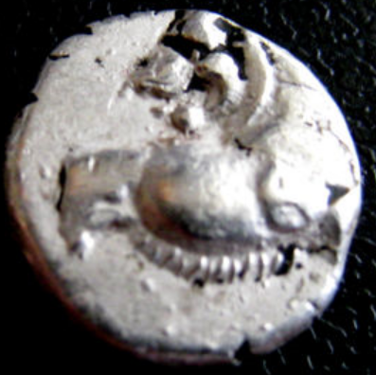 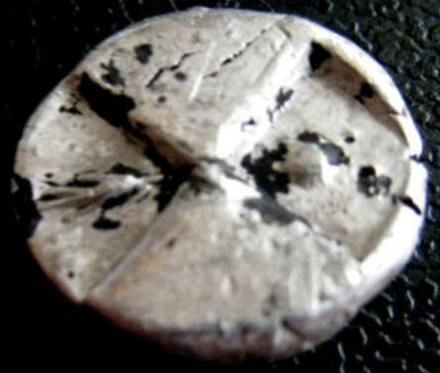

cf. Sear 1603

400-350 BCE AR Hemidrachm, ca. 2-4 gm

Forepart of lion r., looking back, paws raised. R. Duopartite incuse square, the alternate depressions deeper and one containing a pellet, the opposing incuse square has an ear of corn instead of a pellet. BMC 3, p. 183, 8,9.

This specimen 1,84gr  diameter-13mm